FunkyFeets

Group Members

Dhruv Dhola

Jay Chhabra

Smit Shah

PROG8750-24S-Sec4 Capstone (Web Development)

Level 4 Spring 2024

Submitted to

Milan Jacob

# FunkyFeets

## **Introduction**

FunkyFeets offers an advanced e-commerce platform specifically tailored for shoe enthusiasts with the goal of revolutionizing the online shopping experience. FunkyFeets will offer a large selection of fashionable shoes for men, women, and kids, appealing to a wide range of interests and preferences, along with a clean and user-friendly interface.

## **Define/Describe your project**

FunkyFeets will function as a full-service online shoe store, providing a wide selection of shoes that range from dress shoes to sneakers for formal occasions. Customers can choose from a large selection of categories, sizes, and colors to make sure they get the ideal pair for their requirements and tastes. To improve the overall purchasing experience, the portal will also have safe payment choices, easy search capability, and user-friendly navigation.

## **Why do you like to do this project/the benefits of doing this project**

In today's digital landscape, where apps simplify tasks, online shopping, including for shoes, has become increasingly prevalent. FunkyFeets enters this arena as a digital marketplace specializing in footwear, aiming to streamline the shoe-buying process. It offers customers a user-friendly platform to explore an extensive array of shoe options, facilitating convenient browsing and purchase from the comfort of their homes.

Engaging in the FunkyFeets project presents a valuable learning opportunity for participants, allowing them to delve into modern technology stacks such as MongoDB for database management and React for frontend development. As beginners in this area, involvement in FunkyFeets offers hands-on experience, fostering skill development and knowledge acquisition. Furthermore, completing this project will furnish ourselves with a tangible asset to augment our web portfolios, showcasing our proficiency in utilizing contemporary tech stacks for real-world applications.

## **Design and Data Flow**

**Lo-fi design:**

**User Landing Page (Home Page): Lo -fi**

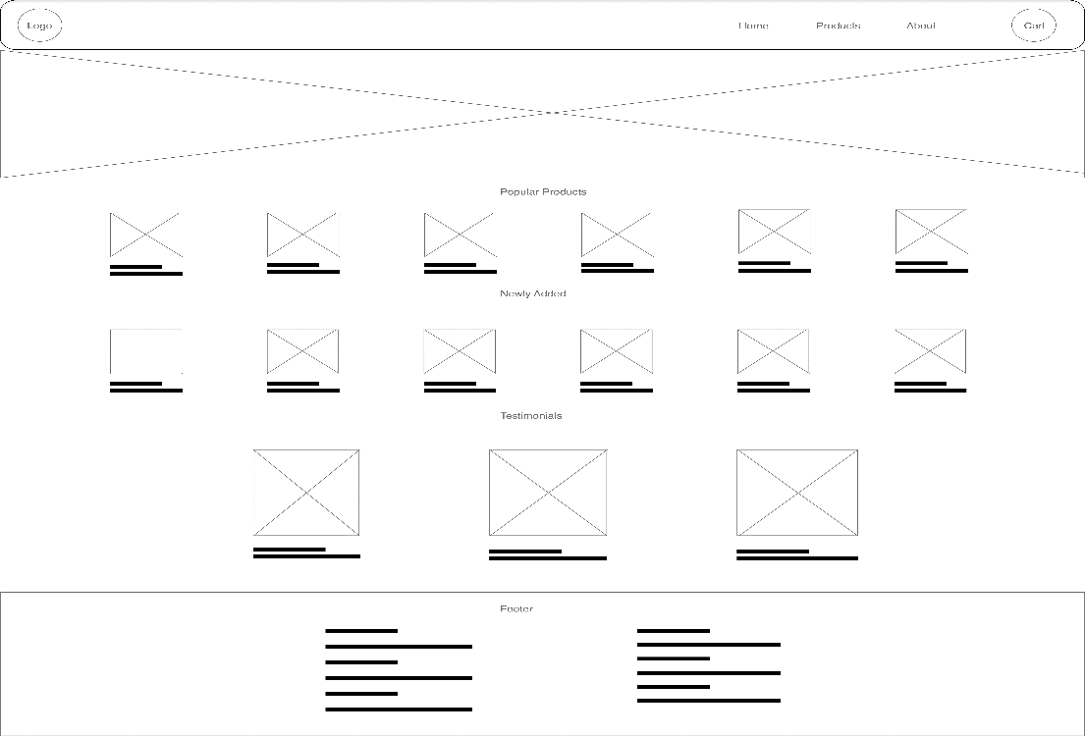

**Products Page: Lo-fi**



Considering the length of the document, we have decided to attach only two Lo-fi diagrams, rest of the designs can be found in **GitHub repository**.

**Data Flow Diagram:** It is a Level – 0 DFD where User, Admin and Payment Gateways are three external entity, and main process is our FunkyFeets system.

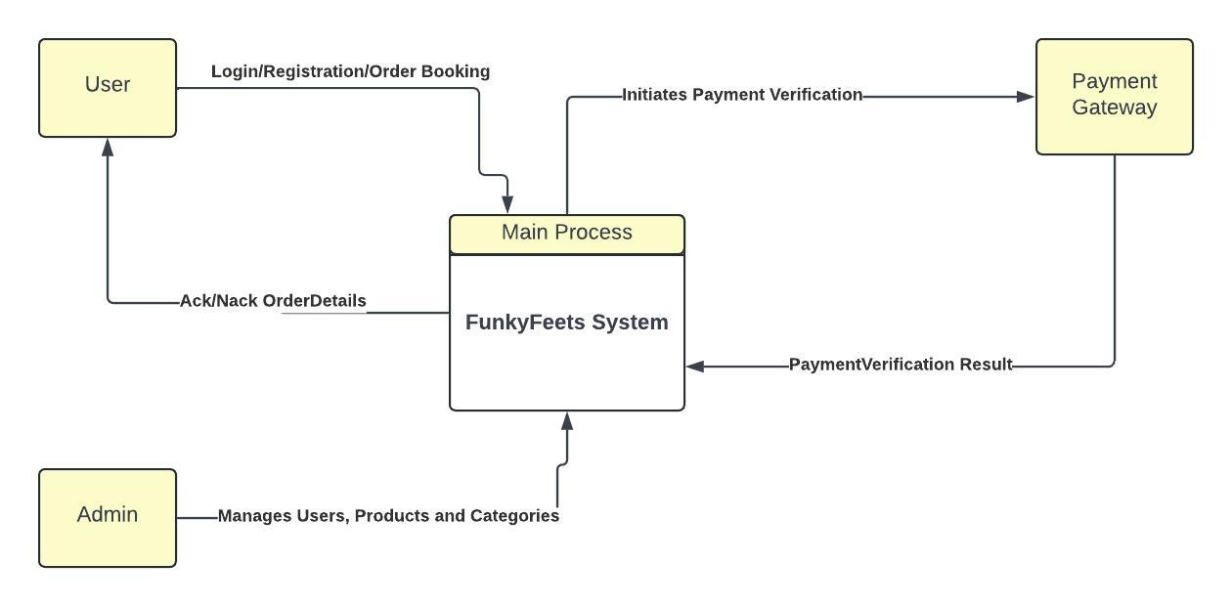

**ER Diagram:** As of now, we have developed a Conceptual ER diagram, which is in 3NF (Third Normal Form).

## **Technology Description**

FunkyFeets is supported by a strong, contemporary technological stack that has been hand-picked to provide a smooth and interesting user experience. The choice of technologies includes:

**MongoDB:** MongoDB serves as the database management system and offers FunkyFeets performance, scalability, and flexibility that are unmatched. Because of its document-based structure, it can handle massive amounts of data that are frequently seen in e-commerce systems in an efficient manner. FunkyFeets' extensive data models are easily integrated with MongoDB, enabling simple data access, modification, and storage.

**React:** FunkyFeets leverages the capabilities of React, a popular JavaScript toolkit that is well-known for its virtual DOM and component-based architecture. FunkyFeets can create dynamic and interactive user interfaces with React, improving users' browsing and purchasing experiences. The streamlined rendering process of React improves overall efficiency and page load times, guaranteeing a fast and responsive user interface. Additionally, FunkyFeets is empowered with the ability to rapidly iterate and develop features thanks to React's vast ecosystem of frameworks and tools.

**HTML/CSS:** The fundamental building elements of FunkyFeets' frontend are HTML and CSS, which give web pages their structure, styling, and layout. FunkyFeets creates aesthetically pleasing and responsive user interfaces that adjust to different screen sizes and devices by utilizing the most recent HTML5 and CSS3 standards.

**Payment Gateway Integration:** To enable safe online purchases, FunkyFeets easily interfaces with a dependable and secure payment gateway. FunkyFeets guarantees that consumers may safely and efficiently make purchases using their preferred payment methods, including credit/debit cards and digital wallets, by integrating with industry-leading payment gateways like PayPal and Stripe. By simplifying the checkout process and fostering confidence and trust in users, the payment gateway integration improves the whole shopping experience.

**GitHub:** FunkyFeets leverages GitHub as a platform for version control and collaboration, making code management, teamwork, and deployment easy. Strong features from GitHub, such pull requests, branching, and issue tracking, make project administration easier and guarantee code integrity all the way through the development process.

With the help of MongoDB, React, GitHub, HTML/CSS, and a smooth integration of payment gateways, FunkyFeets is ready to provide a wonderful and immersive buying experience, raising the bar for online shoe retail.

## **Market Survey**

Based on market research conducted on platforms like LinkedIn and Indeed, we have identified the following ten technologies that are consistently in high demand across various job postings:

* JavaScript
* SQL/No SQL Databases
* HTML/CSS
* React
* Node.js
* Git/GitHub
* RESTful APIs and Microservices
* AWS (Amazon Web Services)
* Docker
* Python

## **Conclusion**

In conclusion, FunkyFeets is an innovative enterprise that is well-positioned to capture the growing internet market for fashionable footwear. With a well-chosen selection of stylish shoes, an easy-to-use interface, and a strong technological base, FunkyFeets is well-positioned to thrive in the ever-changing world of online shopping. We want to launch the product as quickly as possible—in four sprints. Our goal is to bring a variety of cutting-edge innovations that improve user experience, boost functionality, and guarantee continued growth and competitiveness in the market through iterative development cycles.

## **GitHub Link**

FunkyFeets GitHub URL: <https://github.com/jay17chhabra/funky-feets/tree/main>

